**Bash scripts tasks with vdos**

1. If then scripting bash ?

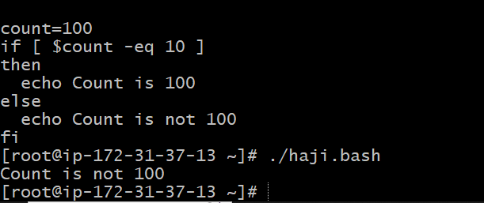

1. Check if file error.text exist?

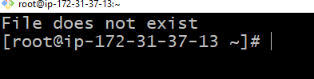

1. Check veriable value is met ?

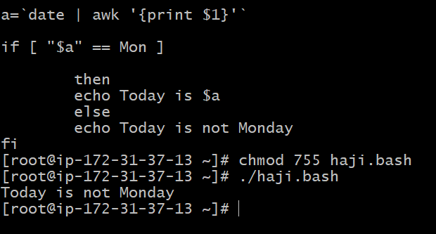

1. Check the response and output

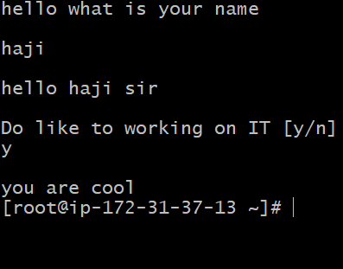

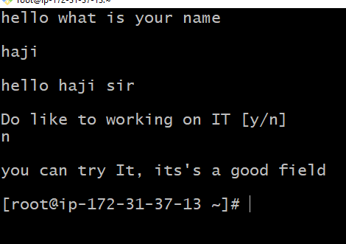

1. Check other if statement

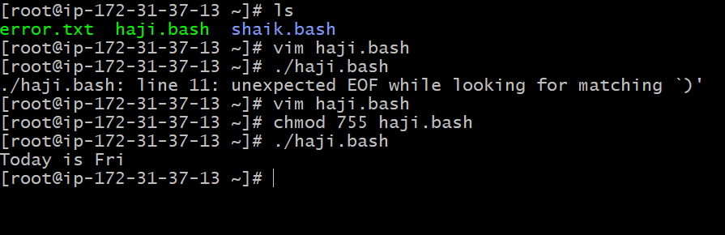

1. Simple for loop output?

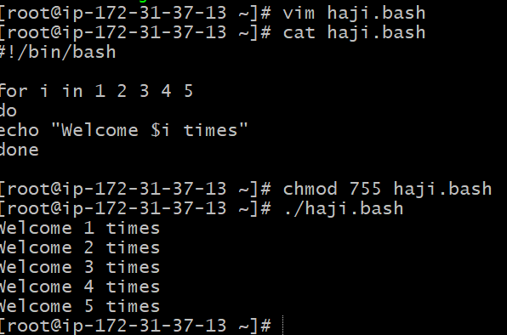

1. **for loop to create 5 files named 1-5**